**Supplementary Requirement Release 2**

1.FV - Field Validation Requirements

   1.1.Field “Deal Title”

**Scope:**

* UC03.01 Create Advertisement SR

**Requirements:**

* Field is mandatory, system will not allow to proceed without Deal Title and system should show the message “Deal cannot be Empty”
  + Field size should be no longer than 30 characters.

**Conditions to Apply:** After the respective join points.

1.2.Field “Offer”

**Scope:**

* UC03.1 Create Advertisement SR

**Requirements:**

* Field is mandatory, system will not allow to proceed without Offer

and system should show the message “Offer cannot be Empty”

* Field size should be no longer than 30 characters.

**Conditions to Apply:** After the respective join points

| 2. 2.DF-In - Data Flow In Requirements |
| --- |

   1.1.Drop-down “Service Type”

**Scope:**

* UC02.3 Search by Service
* UC02.4 Search by location
* UC03.2 Close Advertisement SR

**Requirements:**

* [UC02.3- UC02.4] Drop-down should only contain values entered in service type and service location provided during registering a Service Provider Account.
* [UC03.2] End date for the advertisement will be provided from [UC03.1] when submitting the form for the advertisement.

**Conditions to Apply:** After the respective join points.

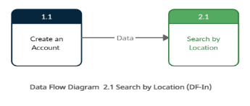

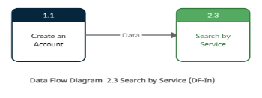

| 3. DF-Out - Data Flow Out Requirements |
| --- |

**Scope:**

* UC03.1 Create Advertisement
* UC03.2 Close Advertisement

**Requirements:**

* Based on the values entered in the Create form the advertisement should appear on the landing page and should be visible when a user signs in.
* Based on the end date for 3.2 the advertisement should be removed from the landing page and should not be visible to the user when he signs in.

**Conditions to Apply:** After the respective join points.

4. Data-Dependency Validation Requirements

4.1. Fields “Service Type” and “Location”

**Scope:**

* UC02.3 Search by Service
* UC02.4 Search by location

**Requirements:**

* If system does not contain the combination of the service and/or the location, the user gets the message “Providers not found”.

**Conditions to Apply:** After the respective join points.

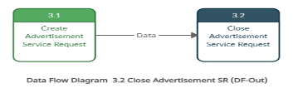

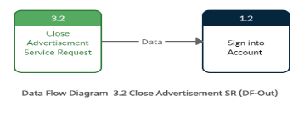

4.2. Fields “Offer Starts From” and “Offer Ends On”

**Scope:**

* UC03.01 Create Advertisement SR

**Requirements:**

* Offer Start Date should be less than Offer End Date and if this is not followed the system shows the message “Start Date should be less than End Date”

**Conditions to Apply:** After the respective join points.